# Developers and Artists: Exploring GAN’s latent space hand in hand

In January 2020 we finalized the development phase of *Marrow*. In this series of posts, Shirin Anlen and I are sharing what we have learned during this process. The [first post](https://medium.com/@s.h.i.r.i.n/7f7db708f06d) was about constructing a well-formed dataset despite having little resources. This post is about working with artists when exploring the latent space of GAN



Shadow animation

## Myself and Marrow

Marrow is a hands-on research initiative and interactive installation by [Shirin Anlen](https://shirin.works), exploring the possibilities of [mental disorders in machine learning](https://immerse.news/when-machines-look-for-order-in-chaos-198fb222b60a). I have previously worked with Shirin on numerous projects, most notably the VR documentary [*Tzina: Symphony of Longing*](https://tzina.space). In 2018, I joined forces with Shirin once more to preview *Marrow* as an installation at [IDFA Doclab 2018](https://www.doclab.org/2018/ive-always-been-jealous-of-other-peoples-families/). The prototype was a success, and one year later we went as co-creators to an intensive development phase produced by the [National Film Board of Canada](https://www.nfb.ca/interactive/marrow/) and [Atlas V](https://atlasv.io/).

## About GAN’s latent space

The [previous post](https://medium.com/@s.h.i.r.i.n/7f7db708f06d) described how we created a dataset of *Perfect family dinner* images and used it to train [StyleGAN V1](https://github.com/NVlabs/stylegan). The result wasn’t perfect, but it was what we aimed for: A distorted image of what it means to be a happy family when your entire life experience comes from internet stock photos.

Our dataset was a bundle of around 6,500 images containing figures of four family members, stripped away from their family dinner setting. Once StyleGAN finished the training process (in fact we stopped it once the quality started to deteriorate), we ended up with a vast space of possible new images containing four distorted familial figures. The infinite, continuous, space of possibilities for an output image is called the [*Latent Space*](https://en.wikipedia.org/wiki/Latent_variable). It is called so, because the output image generated by GAN is determined by a seemingly *hidden* process of mathematical transformations, starting from a series of numbers (in our case 512 numbers), and ending with a bitmap image (in our case a 512x512 image). When you change any of the initial numbers, the resulting image would be slightly different. The transformation network is so deep, that it’s hard to predict what would change.

If you have a good enough dataset and algorithm, you might be able to achieve *disentanglement*: that is when one of those numbers (out of 512) controls one meaningful element in the resulting image; for example, one number changes the age of the generated person while another changes their hair color. Needless to say, we were not able to achieve that with our [small dataset](https://medium.com/@s.h.i.r.i.n/). Changing one number could induce any number of changes in one or more of the four family figures: one family member might change their pose, while another starts to smile, and the third one suddenly puts on a Christmas hat (a repeating motif in stock images, it seems).



Latent space animation

## The Shadow Allegory

As much as visualizing the latent space is intriguing, we were looking for a sharper, more conceptual, and artistic way to talk about the in-between spaces of GAN’s distorted image of the world. Plato’s [Allegory of the cave](https://en.wikipedia.org/wiki/Allegory_of_the_cave) speaks about finding comfort in the simple and flattened representation of things, not being able to face the depth of reality. The people in the allegory are stuck in a cave with a fire burning outside. The fire projects the shadows of passing by objects on the cave’s walls, and that is that all that they can see of reality. They are so used to those shadows, that once one prisoner breaks free, their eyes get burned by the flaring sun. When the prisoner’s eyes are finally accustomed to reality, they come back to the cave to tell the others, but now they are unable to see anything in the darkness. The other prisoners assume that something evil lies outside.

Interestingly, Plato’s allegory of the cave corresponds quite well with the [structure and training process of GAN](https://developers.google.com/machine-learning/gan/gan_structure). GAN is in constant conflict between reality, representations of reality, and fantasy. When the algorithm generates images that are too close to the original dataset, it finds itself stuck in a simple and flat representation of the world, unable to escape to creativity. When GAN’s generations are too fantastical, they are inevitably deemed as fake and wrong. GAN is in a constant struggle to find the balance between the real and the imaginary. Therefore, we decided to visualize GAN’s struggle by using the *shadow representation* of the distorted family outputs.

|  |  |
| --- | --- |
| Full color | Shadow |
|  |  |

## Animating over the latent space

Since the *Marrow* experience happens within a social narrative, we wanted to bring an additional storytelling element into the mix. In the experience, a human character representing GAN is telling her family about her relationship with shadow figures that portray her family. She is being pulled by the shadows into a comforting yet somewhat eerie imaginary world, only to be pulled back into the threatening depths of reality by her family. Hence, we decided to work with an artist, and animate a fantastical layer over the world of shadows. We worked with the talented [Paloma Dawkins](https://palomadawkins.com/), a master of hand-drawn animations and alternate dimensions. Now we had to ask ourselves: how do we orchestrate a workflow that starts in the mathematical depths of GAN, but ends with hand-drawn animations that perfectly match GAN’s latent movements across the latent space? The answer came in the form of our custom-developed tool: *Marrow GAN Explorer*.

## The Marrow GAN Explorer

**The Marrow GAN Explorer is an interactive web-based tool that lets users explore the latent space of** [**StyleGAN V1**](https://github.com/NVlabs/stylegan) **and create chains of key-framed animations between different points on the space.**

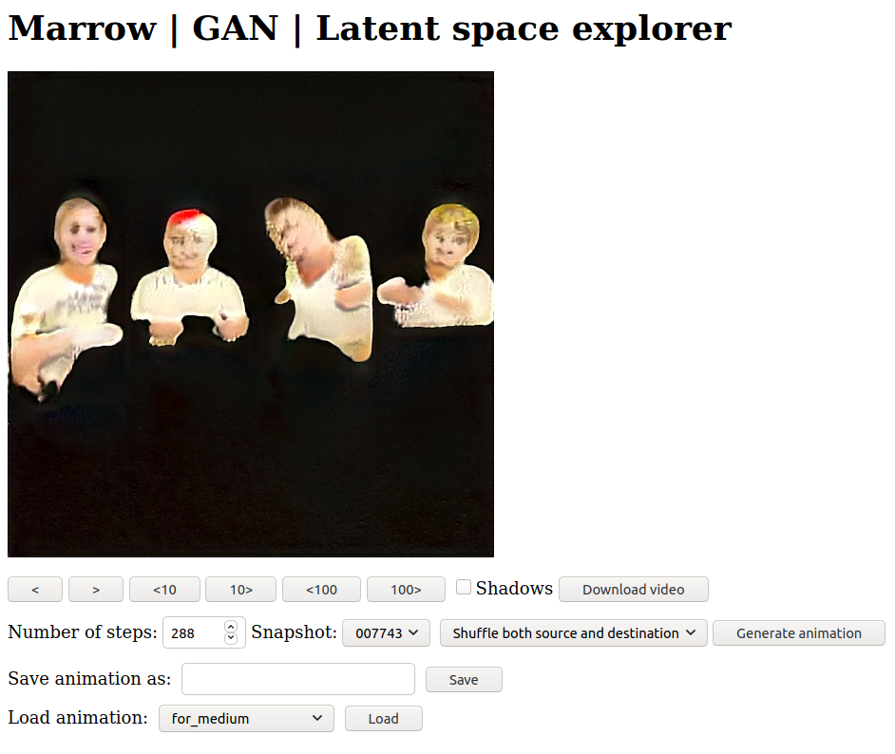

Explorer

### The motivation

The main motivation for the development of this tool was to allow an animator to explore the latent space and choose transitions that they find interesting to animate. Once they make a choice, they can save that sequence in a format that is readable by the machine learning model and can be loaded and inferred in real-time. At the same time, they can save the transition as a video file that they can load in their animation software and animate frame by frame.

### Use-case scenario

The workflow normally works as follows:

1. The animator chooses a *snapshot* of the model, that is, a point in time in the training process. Sometimes, our case included, a snapshot of the model in the middle of training produces better results than the snapshot at the end of the training.
2. The animator chooses the number of *steps*, i.e the number of frames in the animation. The beauty of exploring the latent space is that because it is made of a continuous vector of numbers. One can choose any number of steps and this determines the smoothness of the transition. In our case, the animator was drawing at 12 frames per second, so choosing a 288-step sequence would mean a 24-second long animation.
3. The animator starts by choosing *Shuffle both source and destination* and clicking on *Generate animation*, which produces an entirely new transition sequence.
4. The model now generates a sequence of 288 frames between two ‘families’. The animator can cycle through the frames faster or slower using the arrow buttons. An extra *Shadows* checkbox allows the animator to view the frames either in full color or in ‘shadow mode’.
5. If the animator likes this sequence, they give it a name and save it. The details of the sequence are now saved on the server. If they wish to cycle to another transition, they can go back to stage (1).

### Chaining animations

One of the more neat features of the explorer is the ability to chain animations. Suppose the animator drew a nice 24-second animation for one transition sequence, but now they want to move forward with the story and choose the following sequence. By loading the first transition and then choosing *Use destination as the next source*, the artist can generate a sequence that is a continuation of the previous one. If they liked it, they can save it, but if they didn’t, they can now use the *Keep source and shuffle destination* button to continue cycling between sequences that are all a continuation of the first one.

### Playback in real-time

Once the animations are ready, our GAN streaming engine is ready to load the saved animations and play them back at the desired speed in real-time. Through our main orchestrating engine, we trigger the playback of the animation and the real-time GAN calculation of the sequence at the same time, resulting in a perfectly matched GAN overlay animation.



Shadow animation 2

## The code

The code for the latent space explorer is freely available [here](https://github.com/Raycasters/Marrow/tree/master/gan/gan-explore). It will need adjustments for other projects, but they should be quite simple as long as the model is based on StyleGAN. Migration to other types of GANs should also be relatively simple.

## Under the hood

This section is dedicated to machine learning enthusiasts, listing some of the more interesting features under the hood of the Marrow GAN Explorer.

### Generating transitions with StyleGAN and Numpy

Images are generated from a one-dimensional Z-vectors (‘noise’ vectors) of 512 numbers. Initializing random Z-vectors is easy with Numpy:

self.rnd = np.random.RandomState()  
self.latent_source = self.rnd.randn(512)[None, :]  
self.latent_dest = self.rnd.randn(512)[None, :]

Once we have a source and destination for the transition, interpolations are done using Numpy’s *linespace* function:

self.steps = int(args['steps'])  
self.linespaces = np.linspace(0, 1, self.steps)  
self.linespace_i = 0

To generate the image using StyleGAN, we simply apply the linespace with our source and destination vectors in the following manner:

self.latents = (self.linespaces[self.linespace_i] * self.latent_dest + (1-self.linespaces[self.linespace_i]) * self.latent_source)  
  
images = self.Gs.run(self.latents, None, truncation_psi=0.7, randomize_noise=False, output_transform=self.fmt)  
image = images[0]

Note the *randomize_noise=False* argument. If we were to set it to true, we would still have some random noise added to every image. While this may work well to simulate a more organic output, it doesn’t suit our purpose of matching with a pre-baked animation.

Saving and loading Z-vectors is also very easy with Numpy:

with open('animations/{}/source.npy'.format(args['name']), 'wb+') as source_file:  
 np.save(source_file, self.latent_source)  
...   
# Loading  
self.latent_source = np.load('animations/{}/source.npy'.format(args['animation']))

### Communicating between a Flask web server and a TensorFlow session thread

A TensorFlow session has to run in its own thread, independently of the web server. However, insofar as the web functions have to wait for GAN’s output before returning to the browser, I needed a mechanism for synchronization. I opted to use a threadsafe [queue](https://docs.python.org/3/library/queue.html) to send requests from Flask’s web function to the GAN host, and [asyncio futures](https://docs.python.org/3/library/asyncio-future.html) as a low-level signaling mechanism between GAN and the web functions.

The GAN thread loops indefinitely while waiting for queue requests, and it is aware of the main asyncio loop that running in the background. When Flask gets a *generate* request, it puts a new message in GAN’s queue, along with a new *future* object that is used as the *done* callback:

@app.route('/generate')  
def generate():  
 future = loop.create_future()  
 q.put((future, "generate", request.args))  
 data = loop.run_until_complete(future)  
 return jsonify(result=data)

The GAN thread picks up the message, generates the image and sets the *future* as *done* when it is ready:

(future,request,args) = self.queue.get()  
if request == "generate":  
 ... # Generate the image into a b64text  
 self.loop.call_soon_threadsafe(  
 future.set_result, b64text  
 )

One special handling is needed when a new snapshot is selected. I found that I had to close the TensorFlow session, join the thread, and restart it with the new snapshot:

# At the GAN thread  
if args['snapshot'] != self.current_snapshot:  
 self.current_snapshot = args['snapshot']  
 tf.get_default_session().close()  
 tf.reset_default_graph()  
 break  
  
# At the web server  
global gan  
gan.join()  
args.snapshot = params['snapshot']  
gan = Gan(q, loop, args)  
gan.start()

## Conclusion

Custom web-based tools allow artists and developers (let us assume that there are such definitions for the purpose of this text) to work seamlessly in a machine learning context. In a manner not unlike the process of level design in games, these tools are focused on creation at the frontend but speak the language of modularity and recreation at the backend. We had a lot of fun sitting together, viewing and choosing sequences during the creation of *Marrow*. But while we were witnessing the intense visuals in front of us, the data that was saved on the server was a simple series of numbers that trigger a vast computational network with unforeseen, yet consistent consequences. Likewise, we didn’t always know why we liked a particular sequence, but the decision was often anonymous. Perhaps it was our common intuition.